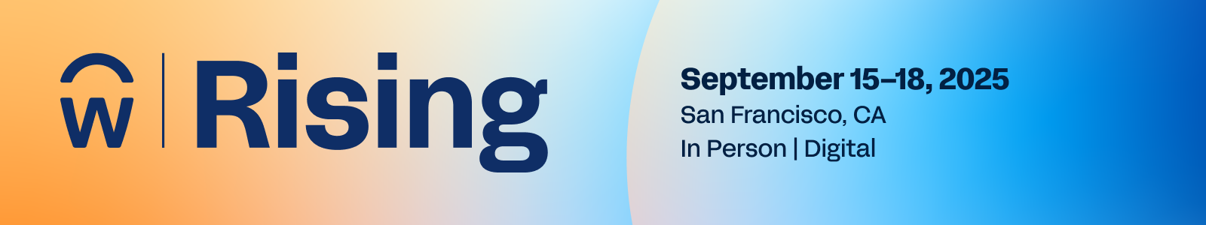

Workday Rising—Request to Attend

Hi [Name],

I’m requesting your approval to attend Workday Rising, taking place September 15–18, 2025 in San Francisco, CA and online. Workday Rising has established itself as the ultimate AI event for moving businesses forward and what’s currently happening in our industry. Attendees can expect to witness customer triumphs fueled by AI-driven automation, roll up their sleeves in hands-on-labs, and connect with experts pioneering the next wave of intelligent enterprise solutions.

Event overview.
Workday Rising is a customer-centric conference for existing and prospective Workday customers to learn how to use the Workday platform to achieve organizational goals. Facilitated by Workday product experts and partners, Workday Rising gives thousands of HR, finance, and IT professionals the opportunity to connect, learn, and discover new ways to maximize their investment.

Benefits.
Attendees report the investment of time and money was justified by learnings that could immediately drive improved outcomes across the organization across four main impact areas. With hundreds of sessions based on role and industry, inspiring keynotes, and networking opportunities, there’s a wealth of knowledge for me to gain and explore as the Workday community comes together.

Plus, for the first time ever, customers can take a Workday Pro Certification Exam at Workday Rising for just $99 (regularly $800).

Projects and initiatives.
Specifically, I’d like to focus on exploring solutions and process improvements for the following projects at our organization:
● [add project or initiative]
● [add project or initiative]
● [add project or initiative]

Cost.
Here’s a breakdown of my approximate conference costs based on flying to San Francisco:

Item | Regular  Begins June 26
Registration Fee | $2,295
Average U.S. Airfare | $600
Ground Transportation | $125
Hotel (3 Nights at $328 pre tax) | $987
Meals/Expenses for 4 days at $100 (3 days of lunches and snacks, with two evening hosted receptions included) | $400
TOTAL | $4,407
Workday Pro Certification (regularly $800) | $99
TOTAL with Workday Pro Certification | $4,506

I’m confident that Workday Rising will benefit our organization, our team, and me. After the conference, I’ll summarize what I’ve learned and share it with our teams.

Thank you in advance for considering this request.

[Signature]

