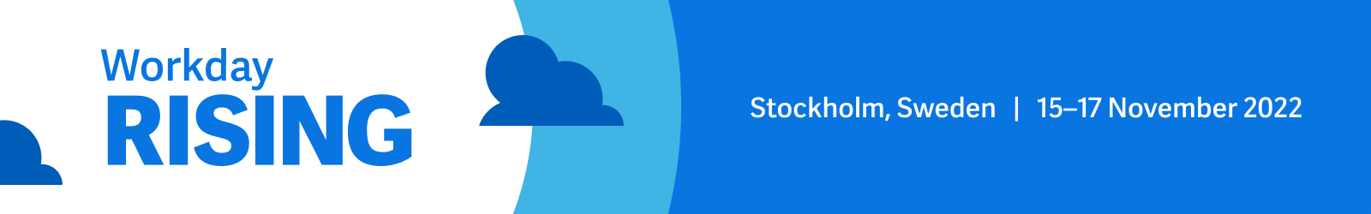
Workday Rising Europe – Request to Attend

Hi [Name],

I’m requesting your approval to attend Workday Rising Europe, taking place on 15–17 November at Stockholmsmassan, Stockholm, Sweden. Workday Rising Europe is where changemakers explore solutions not only for adapting to change, but for driving it. This is a great opportunity for me to see first-hand what differentiates Workday from other finance and HR systems, as well as get inspiration for solving our own business challenges.

In 2019, Workday Rising Europe had more than 3,200 attendees, over 64 partner companies in the Expo, and hundreds of educational sessions. This will be the first in-person event since then, and organisations evaluating Workday are invited to attend the entire conference experience free of charge. I’ll get to make valuable connections, hear how other organisations use Workday, and meet one-on-one with industry leaders and product experts.

Specifically, I’d like to focus on exploring solutions or best practices that could benefit the following projects at our organisation:

- [add project or initiative]

Here’s a breakdown of my approximate conference costs based on flying into Stockholm:

Item | Approx cost
Average airfare | €300
Transport: a round-trip Arlanda express train from the airport to the centre of Stockholm, and then a taxi to the hotel | €60
Hotel: three nights at $250 | €750
Meals/Expenses: breakfast and lunch provided daily, along with two dinner events provided. Three days at €60. | €180
TOTAL | €1,290

I’m confident that attending Workday Rising Europe will help us make an informed technology investment. After the conference, I’ll summarise what I learned and share with key stakeholders throughout the company.

Thanks in advance for considering this request.

